A Study of the Divided Kingdom, part 2
Summer 2015 Course Outline
# | Date | Lesson | Text
1 | July 5 | Isaiah Prophesies to Judah | Isaiah 1-6
2 | July 8 | Judah and Israel Invaded; Pekah (I); Jotham, Ahaz (J) | 2 Kin 15:27 – 16:20; 2 Chr. 27-28; Isa. 7
3 | July 12 | Micah | Micah
4 | July 15 | Hezekiah’s Reforms | 2 Kings 18:1-8; 2 Chron. 29-31
5 | July 19 | Prophecies of Israel’s Future | Isaiah 8-12
6 | July 22 | Israel Falls, Carried into Captivity | 2 Kings 17; 18:9-12
7 | July 26 | Jerusalem Besieged & Delivered | 2 Kin 18:13–19:37; 2 Chr 32:1-23; Is 36-37
8 | July 29 | Hezekiah’s Reign Concludes | 2 Kings 20; 2 Chr. 32:24-33; Isa. 38-39
9 | Aug 2 | Jehovah’s Suffering Servant | Isaiah 49-57
10 | Aug 5 | Manasseh and Amon | 2 Kings 21; 2 Chron. 33
11 | Aug 9 | Zephaniah | Zephaniah
12 | Aug 12 | Josiah Repairs the Temple | 2 Kings 22:1 – 23:3; 2 Chron. 34
13 | Aug 16 | Josiah’s Reforms | 2 Kings 23:4-30; 2 Chron. 35
14 | Aug 19 | Jeremiah’s Call and Commission | Jeremiah 1-6
15 | Aug 23 | Nahum and the Fall of Assyria | Nahum
16 | Aug 26 | Josiah Dies; Jehoahaz Reigns | 2 Kings 23:28-34; 2 Chr. 35:20 – 36:4
17 | Aug 30 | Habakkuk | Habakkuk
18 | Sept 2 | Captivity Prophesied  Jehoiakim; First Group of Captives Taken | Jeremiah 22, 25, 26; 2 Kin. 23:35 – 24:7; 2 Chron. 36:5-8
19 | Sept 6 | Rare Examples of Faithfulness | Daniel 1; Jeremiah 35
20 | Sept 9 | Jehoiachin; Second Group Captive; Zedekiah Installed  Jeremiah’s Messages to Zedekiah | 2 Kings 24:8-20; 2 Chron. 36:9-14;  Jeremiah 21, 28
21 | Sept 13 | Jeremiah’s Messages to the People | Jeremiah 27, 29
22 | Sept 16 | Jeremiah Prophesies a Better Future | Jeremiah 30-33
23 | Sept 20 | Jeremiah Persecuted | Jeremiah 34; 36-38
24 | Sept 23 | The Fall of Jerusalem; Final Captives Taken | 2 Kings 24:17 – 25:26; 2 Chr. 36:11-21;  Jeremiah 39, 52
25 | Sept 27 | Jeremiah Left Behind | Jeremiah 40-44
26 | Sept 30 | Review

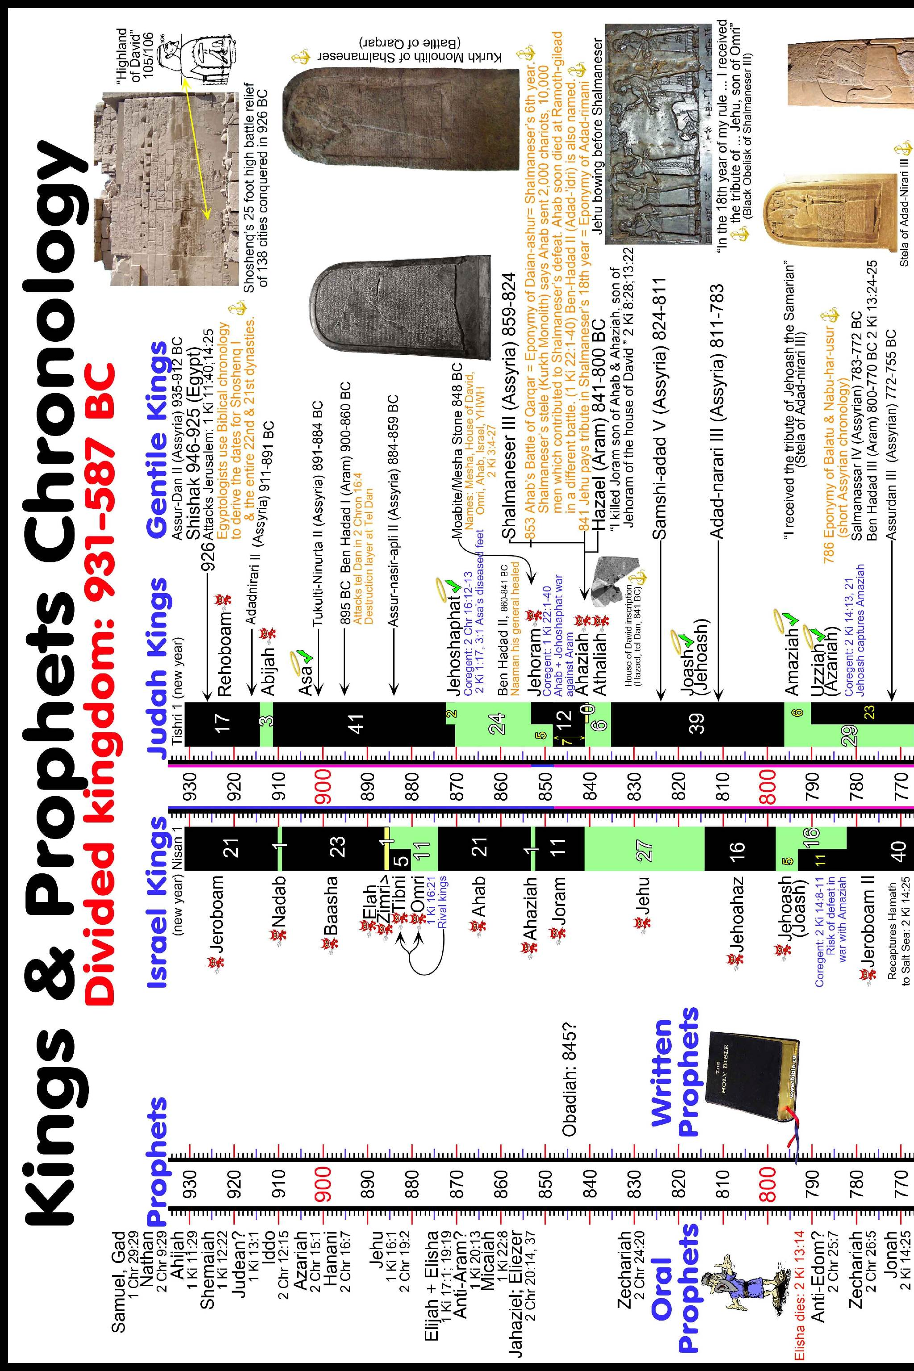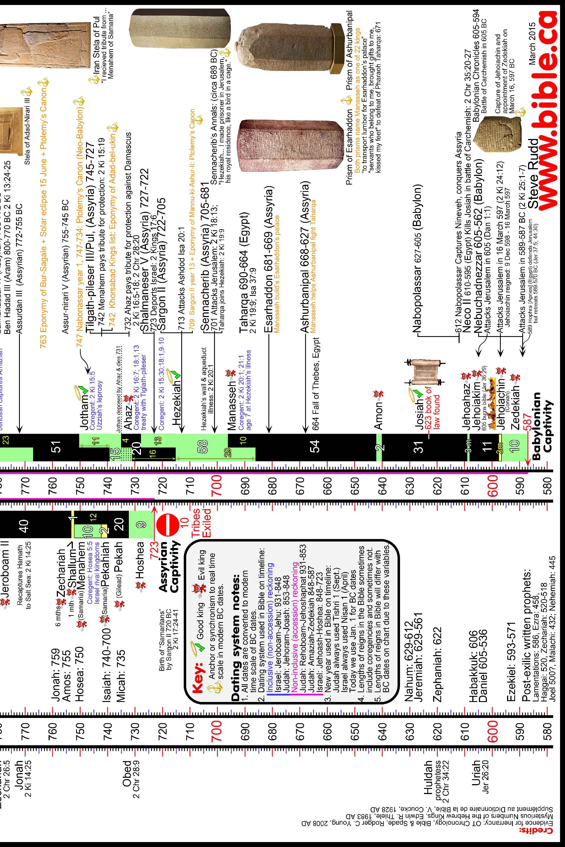
Lesson 1: Isaiah Prophesies to Judah
Isaiah 1
1. What do we know about Isaiah?
2. Is Isaiah prophesying to the leaders of Sodom and Gomorrah in verse 10?
3. What sins were the people guilty of?
Isaiah 2
4. To what do the prophecies of this high mountain, Zion, refer? Verses 2-4 especially.
5. Isaiah talks of the wealth & glory of men being cast away. Who is glorified instead? How?
Isaiah 3
6. What kind of leaders would God appoint for Jerusalem as punishment? Indeed, who was already ruling over them?
7. How would God spoil the beauty of the daughters of Zion?
Isaiah 4
8. What is the significance of verse 1? A great dating opportunity for guys, or something bad?
9. Does verse 1 fit better in this chapter, or the prior one?
10. What time period does the majority of this chapter talk about?
Isaiah 5
11. Explain what the events that happen to the misbehaving vineyard would mean as they applied to Israel.
12. Are there any of these verses that seem to address problems that are with us today?
13. What does God do to his people at the end of this chapter?
Isaiah 6
14. What so terrified Isaiah that he cried out?
15. Are there any phrases in Isaiah's vision of the Lord that stand out, perhaps in a song we sing or something else you may have heard?
Thought question: How is it that God's people kept going back into these same kinds of sins Isaiah speaks of? Think about it from the viewpoint of an ordinary Jew of the day.
Lesson 2: Judah and Israel Invaded; Pekah (I); Jotham, Ahaz (J)
2 Kin 15:27 – 16:20
1. A number of leadership changes take place for both Israel and Judah. List the kings and the order in which they rose to their thrones. Note also if they were good or bad.

2. Outside nations also play a role. Show on a map where Assyria and Syria are and how their locations impacted the events in this reading.
3. Was King Ahaz' action in making the new altar a good, or bad, thing? He was offering sacrifices commanded by God on it, wasn't he?
2 Chr. 27-28
See Steve Rudd's web site on the chronology of the kings, why the lengths of the reigns on his timeline do not match up with the stated ranges in Scripture: http://www.bible.ca/archeology/bible-archeology-maps-timeline-chronology-kings-prophets-assyrians-babylonians-egyptians-tisri-nisan-inclusive-accession-reckoning-divided-kingdom-dates-931-587bc.htm
4. How much did the Ammonites give Jotham in tribute? Would this have been enough for him to "become mighty"?
5. 2Ch 28:5 says Ahaz was defeated, but 2Ki 16:5 says the opposite. 2Ch 28:21 says Assyria did not help Ahaz, but 2Ki 16:9 says he did. Suggest some ways to explain these two apparent contradictions.

Isa. 7
6. What did Isaiah prophesy would happen to Ephraim and Damascus?
7. God told Ahaz to ask for a sign for himself, but he refused. God then gave his own sign, which was what? Was it a sign to Ahaz?
8. Describe the how the land would look, according to the prophecy Isaiah spoke. What does all this mean, and when would it come to pass?
Lesson 3: Micah
"Who is like God?"
Micah
1. Micah uses very descriptive and violent language in his prophecy. Who were prophets contemporary with Micah, and was their speech similar?

2. What sin of the people do we see first mentioned in Micah's prophecy? Was this a common problem with the Jews?
3. Where was Micah from? Where are the cities in Chapter 1 in relation to Micah's home town? Did Micah have a personal stake in what was coming?

4. Chapter 2 is especially harsh against the leaders of the people. List some of their sins.

5. What does Chapter 3 tell us will happen to the wicked leaders, the false prophets, and even the city of Jerusalem?
6. What language of Micah in Chapter 4 sounds just like Isaiah 2 we studied two classes ago? How are these promises a contrast to the leaders of the people at that time?

7. Who is promised to come in Chapter 5? How do we know who he is?
8. What quick history lesson does Micah give the people in Chapter 6?
9. Does God suggest in Chapter 6 that keeping of the sacrifices was unimportant, or does Micah contrast them with something more important to God?
10. The beginning of Chapter 7 refers to a very wicked time. Is this in Micah's day, or some time yet future? Does Jesus refer to this passage or time?
11. With what description of God does Micah conclude? Is it positive or negative?
Lesson 4: Hezekiah’s Reforms
2 Kings 18:1-8
1. What was the character of Hezekiah's reign?

2 Chron. 29-31
2. What condition was the temple in at the beginning of Hezekiah's rule? What did he do about it?

3. Describe the first "worship service" held in the now-consecrated temple.

4. There were too few priests to handle the animal sacrifices. How many animals were brought, and how does this compare to some of the sacrifices that took place in David's time?
5. What does 29:36 mean, "the thing was done suddenly"?

6. In chapter 30, to whom did Hezekiah send invitations to the Passover? Wait, who? Which kingdom was Hezekiah king of again? What does this say about him?

7. What was the people's response to the invitation? For those that came, were they properly prepared according to God's law?

8. Describe the firstfruits offerings brought by the people in Chapter 31. How, exactly, do you think they laid all these things up in heaps for 4 months (vs. 7)?

9. Describe the priests, as Hezekiah set them up.
Lesson 5: Prophecies of Israel’s Future
Isaiah 8-12
- What do you think was the significance of the tablet (some versions say "scroll") in 8:1?
- What did Isaiah foretell was coming?
- Which children does Isaiah mean in 8:18?
- Is there any part of Isaiah 9 that strikes you as familiar? Does identifying that part help to set a time frame for the fulfillment of the surrounding text?
- In the latter part of 9 and first part of 10, what are Israel’s sins?
- What boastful claims does Assyria make in chapter 10? Is God pleased with this?
- What does chapter 10 say will eventually happen to God’s people? Is this Israel or Judah that is spoken of? (i.e. does “Israel” mean the divided kingdom of Israel?)
- Who reappears again in Isaiah’s prophecy in chapter 11? How will 11:6-9 be fulfilled?
- Did God’s people return from captivity? If so, what does verse 11 mean, and where do you see it being fulfilled in the New Testament?
- What is the mood of “that day” as described in chapter 12?
Lesson 6: Israel Falls, Carried into Captivity
2 Kings 17
- What eventually happens to the northern kingdom of Israel? Who was the last reigning king of the northern kingdom?
- Why did this happen to them?
- The text tells us the people turned away from the commandments of the Lord, but what specific sin does the scripture repeatedly tell us Israel was guilty of?
- What very brief summary of the northern kingdom does 17:21-23 give us?

- Who was brought into the land to replace the Israelites?

- What New Testament people/region is explained in 17:24-28? (see also v. 41) Did Jesus ever interact with them?
What a mess!
2 Kings 18:9-12
- Where were the Israelites settled?
Lesson 7: Jerusalem Besieged & Delivered
2 Kin 18:13–19:37
- How desperate was Hezekiah to appease the approaching Assyrian king Sennacherib?
- Who was the Rabshakeh?

- Did the Rabshakeh understand true worship of God, based on his comments in 18:22?
- What claim did the Rabshakeh make in 18:25?
- Whom did the Rabshakeh say the Samaritans worshipped?
- What argument for God’s intervention did Hezekiah make to Isaiah in 19:4? See also 19:16. Did it work?

- What did Isaiah prophesy about the Assyrian invasion?
2 Chr 32:1-23
- What more does 2 Chronicles tell us about Hezekiah’s preparedness to defend against Sennacherib? Was he acting on his own, or had his previous actions (chapter 31) secured God’s blessings?

Is 36-37
- Compare Isaiah 36-37 to the other passages above. How similar are these separate historical accounts?

- Did Isaiah write these two chapters in the book of Isaiah? Did he write the comparable parts in 2 Kings and 2 Chronicles?
- What would you reasonably conclude about these textual similarities?
Lesson 8: Hezekiah’s Reign Concludes
2 Kings 20
- If God knows the future, did He know He would change his mind and let Hezekiah live? Did He lie to Hezekiah in 20:1?

- What are this shadow and steps spoken of between Hezekiah and Isaiah?
- How powerful was Babylon at this time? Compared to Assyria?

- Who eventually carried Judah off into captivity, and when?
2 Chr. 32:24-33
- What description of Hezekiah’s illness and recovery do we get in 2 Chronicles?
- Does 2 Chronicles 32 go into any details about the visit of the Babylonian envoy? What unique detail does it tell us about the real reason for their visit?
- Where else does 32:32 say we can read about Hezekiah? Can we go there and read it?
- When Hezekiah died, where do we see he was buried? Where were kings of Israel usually buried?

Isa. 38-39
- Does Isaiah tell us any more about the “steps” and shadow?
- When Isaiah told Hezekiah what Babylon would eventually do to his family, what was Hezekiah’s response? What do you think of his answer and his thoughts?
Lesson 9: Jehovah’s Suffering Servant
Isaiah 49-57
- Of whom is Isaiah speaking in 49:1-7? Do the comments about God forming him in the womb seem odd to you?

- When would the comfort of Israel come as described in the rest of 49?

- From chapter 50, why did evil times fall upon Israel?

- Did the servant come from within Israel? (50:7-11)

- From 51, what is Zion, as it contrasts with Israel?

- Who would Isaiah’s listeners have been, and what were the circumstances of their times?

- How is it possible (52:1-2) that Jerusalem would no more have any unclean thing enter in? Were they just going to shut the gates, or what?

- Do you recognize 52:7 from anywhere?

- 52:13-53:12 are often said to describe Jesus. What characteristics of Jesus match these details from Isaiah:
52:13 – he shall act wisely and be lifted up
52:14 – his appearance was marred
52:15 – he shall sprinkle many nations
52:15 – they … see and … understand
53:2 – a young plant, root out of dry ground, no form, majesty, beauty
53:3 – despised & rejected of men, acquainted with grief
53:4 – has borne our griefs & sorrows
53:5 – was pierced for our transgressions, with his wounds we are healed
53:6 – our iniquity is laid on him
53:7 – like a lamb to the slaughter, silent
53:9 – grave with the wicked, rich man in death
53:10 – the Lord crushed him
53:12 – divide the spoil with the strong

- Is 54 a happy chapter? What scenes are described that support your view?

- What is the bread and labor that does not satisfy? (55:2) What should they (we) purchase instead?

- Who are the foreigners who join themselves to the Lord in 56:6-7? Does your answer change when you note that they keep the Sabbath?

- What problem afflicts the people in 57:1-13?

Lesson 10: Manasseh and Amon
2 Kings 21
- Contrast Manasseh with Hezekiah.

- What is meant by “the measuring line of Samaria… the plumb line of the house of Ahab”?

- Check your Divided Kingdom timeline. Were Manasseh and Hezekiah co-regents for a time? Do you think Manasseh learned anything from Hezekiah?

- Did Amon, son of Manasseh, reign long enough for the Lord to get angry with him?

- What king comes on the scene next, was his ascent to the throne slow or swift, and what do you know about him?
2 Chron. 33
- What was doubly insulting about Manasseh’s actions in 33:7?

- Wow. Chronicles really sheds some interesting light on Manasseh’s actions later in life. What more do we learn?

- What were the Chronicles of the Seers (or “of Hozai”)?
Lesson 11: Zephaniah
Zephaniah
- Who was Zephaniah, and when does he come on the scene?

- Describe the state of Israelite religion under the previous kings we’ve just studied about, Hezekiah, Manasseh, and Amon.

- What day of the Lord was near (1:7) in which He would do the things he promises in 1-6?

- Is Zephaniah 2 against Judah? What nations are spoken against?

- Do the Israelites ever plunder their enemies as described in 2:9?

- Who is the focus of 3:1-8?

- What happens in 3:9ff?

- Zephaniah is sort of like Isaiah, except that he has only 3 chapters to get everything in. Give a quick outline of the prophecy of Zephaniah.
Lesson 12: Josiah Repairs the Temple
2 Kings 22:1 – 23:3
- How old was… no, everybody asks that, and it’s in the first verse. Explain how such a young king might have come onto the throne before he was quite ready. (look back)

- What’s the first main public work we read of Josiah undertaking?

- Why is this significant, given the deeds of his predecessors?

- Why might an honest construction worker appreciate not having to give an accounting of the money given to him? (22:5-7) What kind of men had Josiah hired to do the work?

- How does God’s providence seem to work for good in Josiah’s choice of projects? (22:8)

- Who was the one that read the Law to the people?

- Should the leader of the people set a moral example?

2 Chron. 34
- What organization of the workers does Chronicles detail for us?

- To whom did the king’s people have to go in order to inquire of the Lord? Couldn’t the high priest have just asked God himself? (What was the state of religion in Judah at this time?)

- What coming disaster did Zephaniah prophesy against Judah in the days of Josiah? How does this agree with the answer the Lord sent back to Josiah from the prophetess?
Lesson 13: Josiah’s Reforms
2 Kings 23:4-30
- What does your translation say about the abominations found in the house of God in 23:4-7? How horrid is something like that when compared to the respect, reverence, and care that righteous priests would have taken in their dealings with God’s house?

- What previous kings’ works of idolatry did Josiah undo? Any surprising names in that list?

- How many different places are mentioned where idolatry was practiced in and around Jerusalem? Is it any wonder God was upset?

- What historical figure’s bones did Josiah not disturb on the mountain top?

- Josiah was king over which of the two kingdoms? Yet how far are we told his reforms went? (23:19)

2 Chron. 35
- What were the priests apparently doing with the ark of the covenant?

- What feast did the king have the people keep for the first time in a long, long time? How long had it been?

- Josiah had such a promising reign. What event happened that ended his life?

- Was Pharaoh Neco actually on a mission from God? Why do you believe so or not?
Lesson 14: Jeremiah’s Call and Commission
Jeremiah 1-6
Chapter 1
1. During whose reign did Jeremiah prophesy, and what was the religious condition of the people at that time?

2. Does 1:5 prove all unborn infants are people and known by God? Does God also know everyone before they were even conceived, and are they therefore people before they even exist physically? Does God plan everyone's careers before they are born?

3. How old do you think Jeremiah was, based on 1:6?

4. Did God give Joshua the words to speak, or did he tell him what to write? (1:9)

5. What had Israel been like to God in "their youth"? Then what happened?
Chapter 2
6. What does God ask Israel in 2:11? To what does He compare this in 2:13?

7. To whom had Israel enslaved themselves? Could they make themselves clean again?

8. What does God say they should do when they find themselves in trouble?
Chapter 3
9. God continues a very harsh thought in this chapter from earlier ones, about idolatry. How does He describe it?

10. Where was the northern kingdom of Israel at this time? God describes Israel and Judah as sisters. What had He done to Israel as an example to Judah?

Chapter 4
11. What exactly was coming from the North? To what does God compare it?
12. Who is it in anguish in verse 19?

Chapter 5
13. Did Jeremiah's (the Lord's) pleas have any effect on Jerusalem?

Chapter 6
14. From verses 16 and 17, what had the Lord encouraged them to do? Who would witness the outcome? (18-19)
Lesson 15: Nahum and the Fall of Assyria
Nahum
- Nahum is so long-winded about himself, so what exactly do we know about him?

- Does Nahum name any actual peoples in his prophecy that would help us identify when it was written, and to (against) whom?

- What kingdom is Nineveh a part of?

- What other famous prophet do you know who had been sent to Nineveh, and what was that outcome?

- Hello! Why does 1:15 sound so familiar?

- Why is God pronouncing judgment against Nineveh?

- What promises does God make for Judah’s future?

- What other nation does Nahum reference as an example of what was in store for Nineveh?
Lesson 16: Josiah Dies; Jehoahaz Reigns
2 Kings 23:28-34
- Josiah was such a good king. What was Josiah thinking in the incident with Pharaoh Neco?

- What implications did Josiah’s actions against the Pharaoh have for his kingdom after his death?

- How long was Jehoahaz’s reign in Jerusalem? Was this long enough to establish himself as a good or bad king?

- Does his replacement, and who put him on the throne, surprise you?

2 Chr. 35:20 – 36:4
- So, looking back a few classes, what did you decide about whether Pharaoh was actually on a mission for God, or not?

- 2 Kings 23:29 suggests Pharaoh saw, and possibly recognized, Josiah, and killed him intentionally. What sense does the passage in 2 Chronicles give of the incident?

- What noteworthy individual joined in mourning Josiah? What nickname did that individual have?

- It’s just speculation, but do you have any thoughts as to why one son was taken away and another put on the throne?
Lesson 17: Habakkuk
Habakkuk
- What do we know about Habakkuk?

- How do we date the book?

- What other prophet was Habakkuk a contemporary of?

- Do you see any comparison between Habakkuk’s cry in 1:1-4 and our lives today? Where was the wickedness Habakkuk was looking upon?

- What great, unbelievable work did God say he was working among the nations? To what purpose?

- Habakkuk 2:2-4 pictures the patience of those who live by faith. What were the faithful being encouraged to wait on?

- Are the woes of 2:6-20 pronounced against the Babylonians, or against the wicked of God’s people?

- In chapter 3 it appears that Habakkuk finally understands God’s long range plan. What is the tone of the last chapter?

- How would you outline the overall book, with Habakkuk’s questioning of God and God’s responses?

- What is further suggested about Habakkuk by the tag line at the end of 3:19?
Lesson 18: Captivity Prophesied; Jehoiakim; First Group of Captives Taken
Jeremiah 22, 25, 26
- Do we read of a “Shallum, son of Josiah” anywhere? Who would this have to be, comparing to the Kings and Chronicles accounts?

- To what other son of Josiah does Jeremiah prophesy?

- Who is Coniah, son of Jehoiakim?

- Jeremiah 25 lists several nations that were to suffer God’s wrath. Who are they, and how did God’s wrath find them all? Which nation is mentioned last of all?

- What was the people’s response to God’s message through Jeremiah in chapter 26? Were you surprised?

2 Kin. 23:35 – 24:7
- Whom did Jehoiakim rebel against?

- List the people sent against him by God:

2 Chron. 36:5-8
- Where does Jehoiakim eventually end up?

- What else was taken away?
Lesson 19: Rare Examples of Faithfulness
Daniel 1
- What was taken to Babylon during this first captivity?

- What remained behind?

- Why do we use Daniel’s Hebrew name, but Hananiah, Mishael, and Azariah’s Babylonian names?
- What test of faith did these young men undergo?
- What was wrong with the king’s wine and food? Was it nutritious?

- Is it probable that the four young men became “fatter in flesh” (English Standard Version) because they ate vegetables and drank water?

- Would it have been hard to serve a king that had taken your people away into captivity and robbed your holy temple?
Jeremiah 35
- What was the timing of this chapter, relative to Daniel’s story?

- Who were the Rechabites, and why were they allowed into the Lord’s house?

- If they did not plant nor have vineyards or fields, how did they feed themselves? Weren’t they sinning by not providing for themselves and the tithes and offerings God commanded of His people?

- What is the Lord’s point to Israel about these interesting, but obedient members of the house of Rechab?
- How did God reward this faithful house, and why? Were they keeping the Lord’s commandments?
Lesson 20: Jehoiachin; Second Group Captive; Zedekiah Installed; Jeremiah’s Messages to Zedekiah
2 Kings 24:8-20
- How evil do you have to be to get a bad reputation from God in only 3 months?
- When Nebuchadnezzar besieges Jerusalem in this text, is this the second time he came against the city? If so, why was there anything left to besiege, and who would have defended it?

- What would it have been like to have been Zedekiah and reign over this Jerusalem?

- What jaw-dropping statement just gets stuck in at the end of the chapter? Your reaction?

2 Chron. 36:9-14
- By whom did Nebuchadnezzar, heathen king of Babylon, make Zedekiah, Israelite king of God’s people, swear his allegiance? How upside down is that?

- Did it work? What does this say about Zedekiah’s character?

Jeremiah 21, 28
- Zedekiah had some nerve, sending them to Jeremiah to ask that. Who, and what?

- What simple choice did God give the inhabitants of Jerusalem?
- In chapter 28, what good news did Hananiah seemingly deliver to the people?

- What visual aid did he use in delivering his message?
- Did Jeremiah strongly rebuke him for his message, or what?

- What did the Lord send Jeremiah to say to Hananiah? What was the end result?
Lesson 21: Jeremiah’s Messages to the People
Jeremiah 27
- What visual aid did God have Jeremiah wear?
- To which kings did God send messages by way of Jeremiah?

- Did God seem to have a special relationship with Nebuchadnezzar that was different than he had with other heathen kings?

- What did God say would eventually happen to Nebuchadnezzar’s kingdom?

- What instructions did God give to the kings of the nations around the promised land?

- To Zedekiah, king of Judah?

- To the priests and all the people?

Jeremiah 29
- What is God’s simple message to the exiles in Babylon?

- What was going to happen to the false prophets that were lying to the exiles?

- Explain who said what in the letter exchange between Shemaiah and Jeremiah.
Lesson 22: Jeremiah Prophesies a Better Future
Jeremiah 30-33
- God told Jeremiah to write down what He had spoken to him. Who did the writing of the words in the book? Did the divine guidance happen when God spoke it, or when Jeremiah wrote it down?

- Did God’s message to the people in 30:8 sound anything like the messages of the false prophets from back in chapter 28? What was different about God’s message?

- In 30:24, God says at a later time they would understand things. As is the case with many prophecies, God’s message is very poetic, with a lot of descriptive language. Boil it down into the very simple terms we understand it today (see the first part of this verse for a hint):

- From 31:8-14, what great event was coming? Is the description one of joy or sorrow?

- Out of nowhere, 31:15 is put in the text. Of what event in the New Testament is the verse applied as a prophecy, and how does it fit into the context of Israel’s joyous return?

- The parable of the sour grapes is mentioned in 31:29-30. What other prophet addresses this parable in more detail? When did he prophesy?

- What/when is the New Covenant of 31:31-34? How do you know?

- What unusual thing does Jeremiah do in chapter 32? Why?

- Jeremiah recaps Israel’s history beginning with the Exodus, and ends with this unusual act God commanded him to do. Does Jeremiah question the reasoning behind it?

- The reading ends in chapter 33 with God’s mention of the covenant He made with the house of David so many years prior. Could that covenant be broken? What natural events does God compare His covenant with David to, as a surety of their continuation?
Lesson 23: Jeremiah Persecuted
Jeremiah 34; 36-38
- There is a lot of dialog that goes on between God and Jeremiah while the city is under attack. Where was Jeremiah all this time?

- What had happened involving the enslaving of Hebrews by other Hebrews? What was God’s ruling on the events?

- In chapter 36, how did Jeremiah get God’s message out to the people?

- What was the result of that preaching attempt?

- In chapter 37, it appears that some help is on the way from the south. Who? Do they end up helping Jerusalem?

- Why was Jeremiah imprisoned at this time?

- In chapter 38, Jeremiah is more harshly treated for his message of surrender to the Chaldeans. Where is he placed this time?

- In spite of Jeremiah’s repeated bad treatment, Zedekiah still has the nerve to come to Jeremiah in secret and inquire of the Lord by him. Does Jeremiah respond with “ask Him yourself?” What is Jeremiah’s response, and what does that tell us about his character?

Go back and take another look at the timeline. Refresh in your memory where we are in Israel’s history, who is outside, and what’s about to happen to Jerusalem.
Lesson 24: The Fall of Jerusalem; Final Captives Taken
2 Kings 24:17 – 25:26
- So, how did that “rebellion against Nebuchadnezzar” thing work out for Zedekiah?

- What would be the reason for leaving the poorest people behind in a conquered land?

- What happened to the chief priest and the other temple officials?

- Why do you think the captains of the Hebrew army wanted to put Gedaliah to death? (see what you think now, but realize in the next lesson, you may get more information)

2 Chr. 36:11-21
- How long was it prophesied that the Babylonian captivity would last?

Jeremiah 39, 52
- Jeremiah 39 starts off with a narrative much like the other two accounts. We do, however, discover what happens to Jeremiah. Nebuzaradan, captain of Nebuchadnezzar’s guard, is given special instructions. What are they, and do you find them to be a bit unusual for a conquering commander?

- Who was Ebed-melech the Ethiopian?

- What fruit is specifically mentioned as decorating the ornaments of the temple? Look up how often it appears in connection with the temple. It is also rumored in Hebrew literature to be the “forbidden fruit” of the garden of Eden.

- Jeremiah 52:31 names the king of Babylon as Evil-merodach. What’s up with that?
Lesson 25: Jeremiah Left Behind
Jeremiah 40-44
- How did Nebuzaradan treat Jeremiah?

- To whom did Jeremiah go to live?

- Who was secretly plotting against Gedaliah, the governor appointed by Nebuchadnezzar?

- Were the captains who originally came together to Gedaliah (40:8) in league with each other against the governor?

- From whom do the people seek advice, once they realize Babylon will not appreciate their appointed governor being murdered?

- What is God’s instruction to the people, and did they heed His warning?

- What logic do the people use to justify their idolatry?

- So, where does the sad story of Judah’s rebellion against God finally end up? What damage was done to them and to the nations around them?
Lesson 26: Review
- Review the prophets God sent during this time period. List them, who they spoke to, where they were, and the basic message of each.

- Who were the good kings of this time period? Please try to list even those who did some evil, but also were mentioned as doing some good things.

- What was the relationship between the northern and southern kingdoms like?

- From what you’ve learned of this time period in Israel’s history, if you fear God and don’t want to anger him, what is the one thing that you should never, ever, ever do?

- What sin did the captivity seem to cure the people of, finally?

Over the course of this class, we’ve seen God’s people prosper and then get prideful, dividing the great kingdom God established. The northern kingdom then forgot God entirely, and then got carried away, leaving the smaller southern kingdom, then they repeated the cycle and were mostly carried away, leaving only a smaller remnant. Those poor who were left behind also rebelled and fled to Egypt, in defiance vowing to worship the queen of the heavens instead of God, shaking their fists in God’s face even as he sends Babylon to destroy not only this scrap of Hebrews remaining, but also the nation of Egypt where they took refuge. It didn’t matter how much God beat down Israel for their sins, they just never learned. It took living in captivity to break their rebellious spirit.

